

**Practice Modelling and Simulation**

**Individual Assignment**

**Term1**

**Arnhem, April 2021**

**Master Engineering Systems**

Raana Fardanian

662277

**Scenario 1**: By simulating the scenario1 (48V as step input) as excepted there is no current and angular velocity due to lack of input to the system before 0.1s. The initial spices within time before voltage implementation was not something that I expected. It could be because of the load of the system and initial force needed to start.

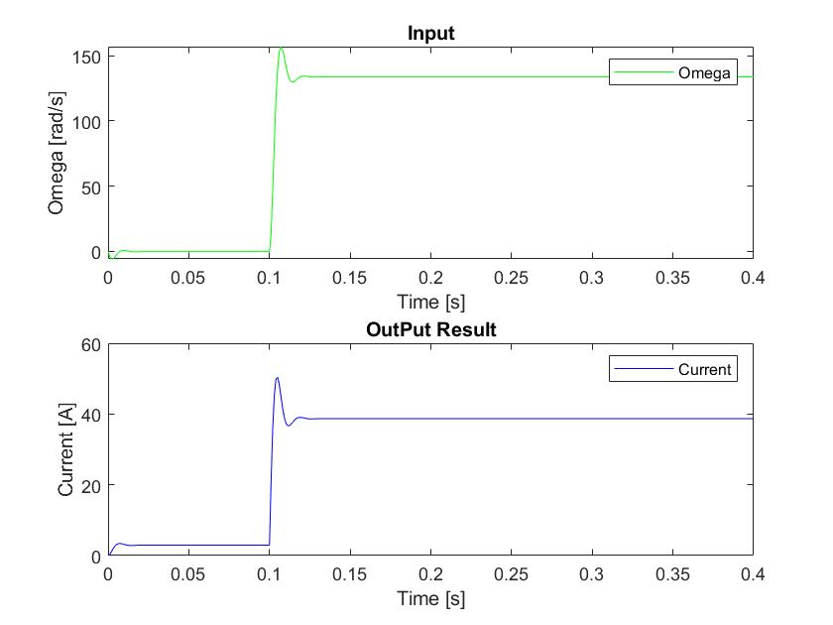

Fig1: Current and Omega scenario 1

**Scenario 2:** In scenario2 by including vehicle velocity as input, during the period of time that velocity increase by slope from 0 to 10 [m/s] due to direct relation with load force and load Torque, angular velocity will be decreased while more load torque cause decrement in angular velocity and during constant velocity, angular velocity remains constant. However, electrical current behavior is same as velocity. By increasing velocity current will increase and when velocity keep constant, current remains constant too.

Overall, as excepted Current has direct relation with velocity and omega has reverse to impact of load force and torque.

Please note that the spice in omega caused by sudden change in velocity trend.

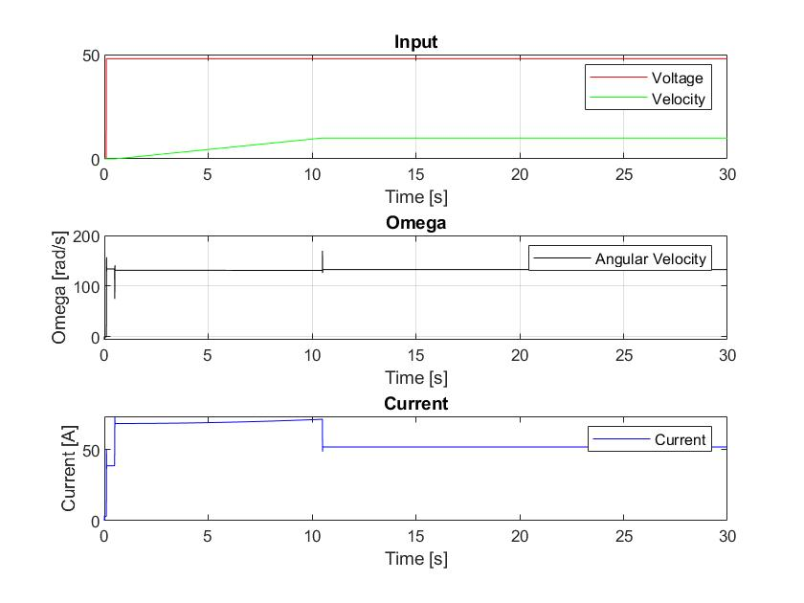

Fig2: Current, Omega and Inputs scenario 2

**Scenario3:** As we had option to choose velocity, I made decision to expand velocity increment with different slopes and investigate the result. As expected, due to the relation between velocity and omega (reverse relation), current (direct relation), same result has been shown in figures.

The changes of current depend on slope of velocity (acceleration of vehicle). It means that if we have more slope in velocity, the current increase more and vice versa.

About the behaviors of Omega, changes are not significantly but the trend is reverse in comparison with velocity.

In last 1.5 s due to saturation in velocity to avoid exceed more than 10 m/s, both Omega and current remain constant.

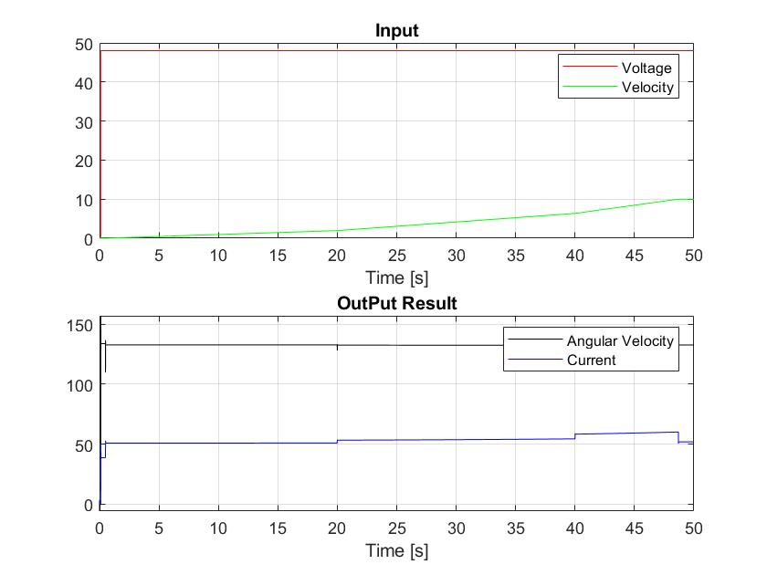

Fig3: Current, Omega and inputs scenario 3

**Validation:**

1. Firstly, we compare our system output with validation file as mentioned in assignment.

There is deviation in result especially in current as output. The difference in Omega is not obvious while the changes in Omega is not significant. The reason of this deviation is different input that considered for the system. In below you can find the difference between out velocity and input and validation file. There is difference in slope as well, we considered the slope for our system as a constant. However, in validation files in varied in time.

Secondly, We consider validation file’s input for system to compare the outputs and check if they are compatible or not.

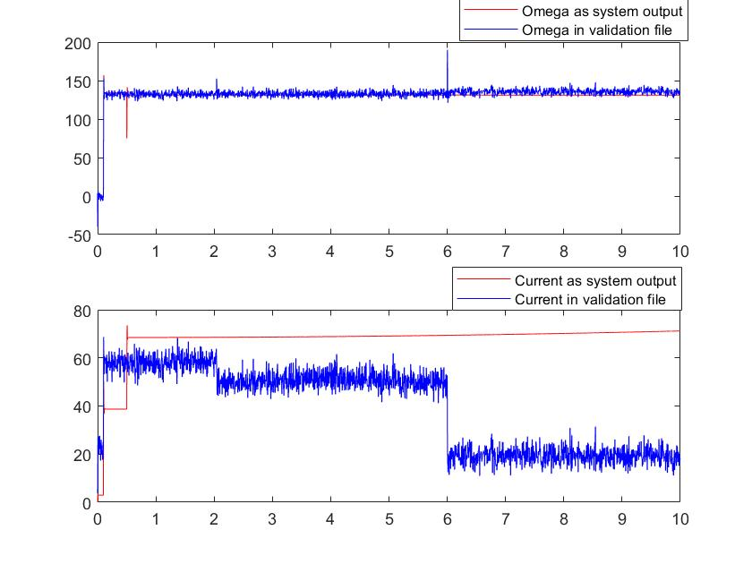

Fig 4: Comparison between Omega and current of Simulink and validation file

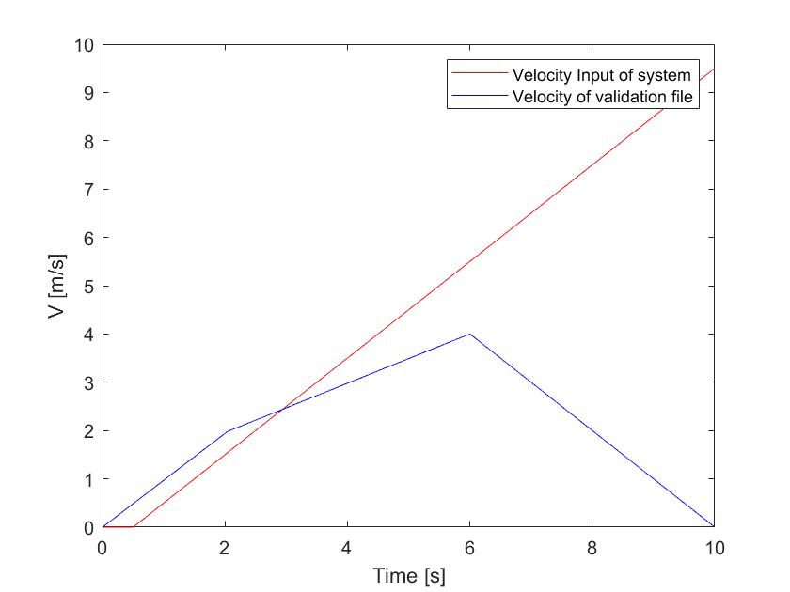

Fig 5: Different between Simulink and validation file Input

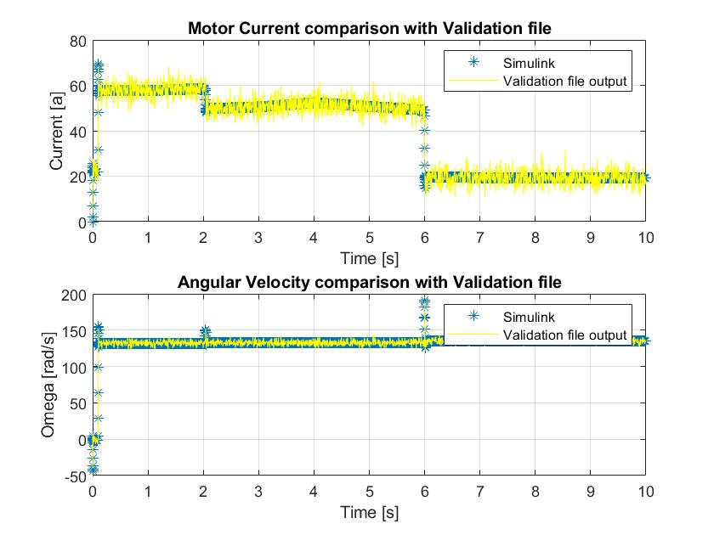

Fig 6: Comparison of validation file and Simulink outputs with same input

1. In this step, varied value defined for variables:

As we can seen in result plot there is not significant changes by changing J, then I zoomed in peaks to make it more visible. By changing I and b, it makes some different in current result but angular velocity not changed obviously. Perhaps it is because of changes happen in load value.

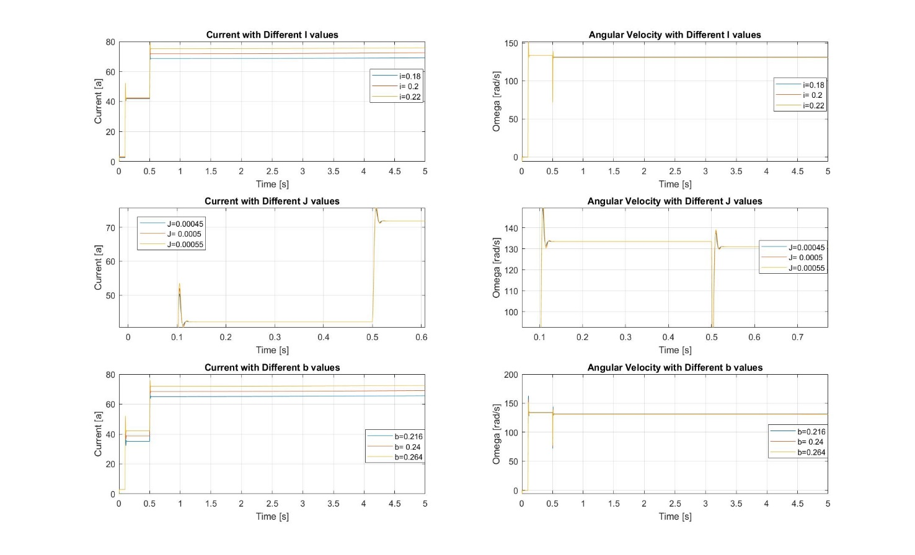

Fig 7: Different value of I,J and b

**State Space:**

Based on current and omega, state space calculated as below:

🡺

🡺

B= $\left[\begin{matrix}\frac{1}{L } & 0 \\ 0 & \frac{-1}{J}\end{matrix}\right] C=\left[\begin{matrix}1 & 0 \\ 0 & 1\end{matrix}\right]$ D= $\left[\begin{matrix}0 & 0 \\ 0 & 0\end{matrix}\right]$

Due to two input in state space, we used mux then all the matrix should be 2*2.

**Transfer Function:**

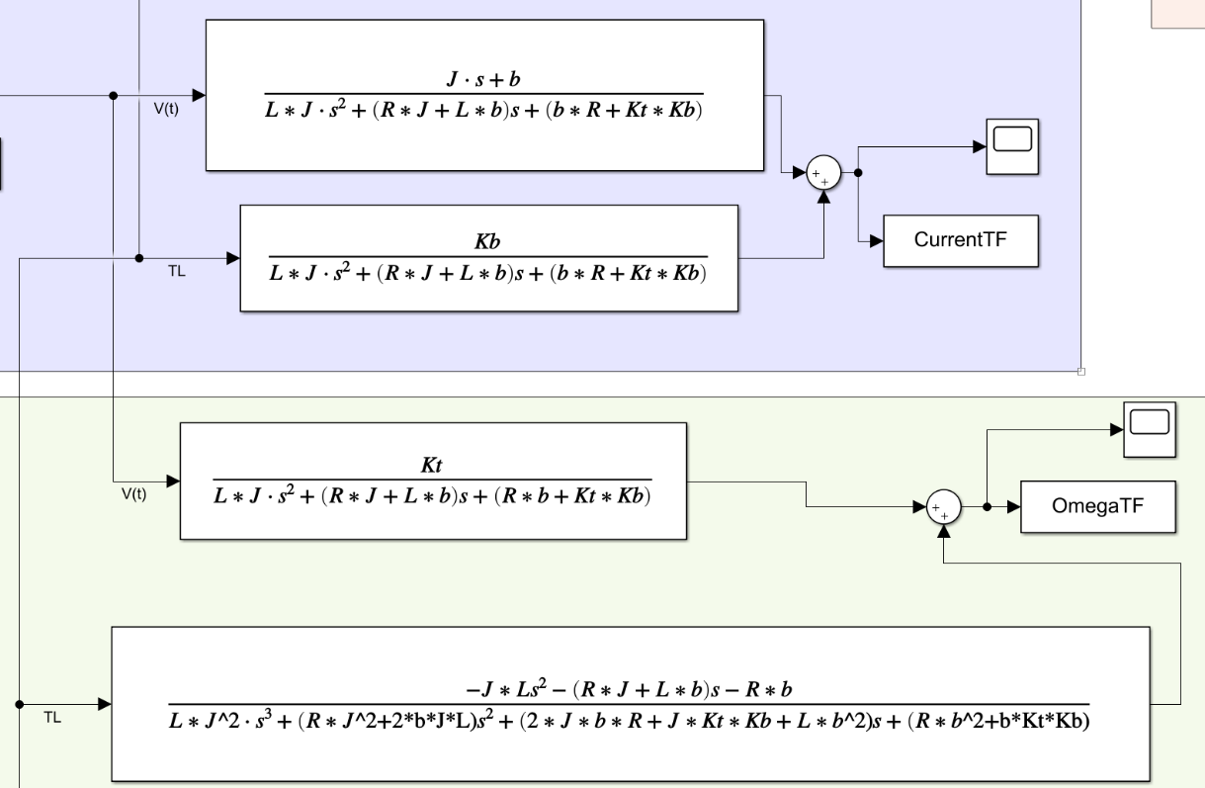

Fig 8: Transfer Function of Current and Omega

Comparison between Space state, Transfer Function and Deferential Equation.

Based on following plot, same result received from State Space, Transfer function and Differential equation.

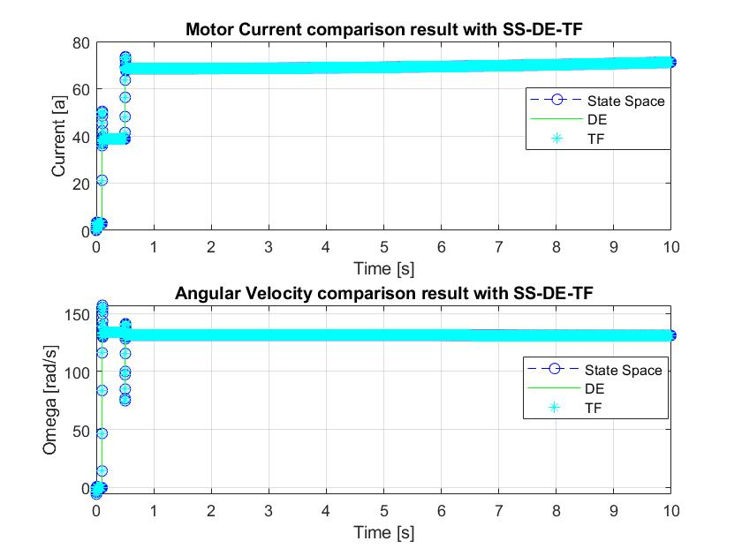

Fig 9: Comparison of Differential equation, transfer function and state space